# An overview of different EBS volume types on AWS

EBS (**Elastic Block Storage**) volume is a block storage device connected to EBS backed instances. These block storage devices can be accessed on the instance just like a hard drive. This **is Zonal service**. Amazon provides 3 different categories of storage drives, and each category includes different types of EBS volumes. Following is the detailed list of EBS volumes provided by Amazon.

Add more details like throughput, iops, etc

* **Solid State Drives** (SSD)
  + General Purpose SSD
  + Provisioned IOPS SSD
* **Hard Disk Drives** (HDD)
  + Throughput Optimized HDD
  + Cold HDD
* **Previous Generation**
  + Magnetic

## Solid State Drives (SSD)

Solid State Drives are useful for loads that include frequent read writes to the drive (High IOPS) with lower IOPS size (lower throughput). The dominant performance attribute for SSDs is IOPS. Now we will discuss different categories of EBS volumes under SSD-backed volumes.

## General purpose SSD

The General-purpose SSD drives provide a balance between the performance and the case. These EBS volumes are recommended for most of the use cases by Amazon. There are two types of General-purpose SSD volumes that are **gp2** and **gp3**.

The General-purpose SSD volume (**gp3**) provides the consistent 125 MiB/s throughput and 3000 IOPS within the price of provisioned storage. Additional IOPS (up to 16,000) and throughput (1000 MiB/s) can be provisioned with an additional price. The General-purpose SSD volume (**gp2**) provides 3 IOPS per GiB storage provisioned with a minimum of 100 IOPS. Similarly, the volumes provisioned with 5333 GiB or larger (up to 16 TiB) will have a maximum of 16,000 IOPS

Following is the performance chart of both types of General-purpose SSD volumes.

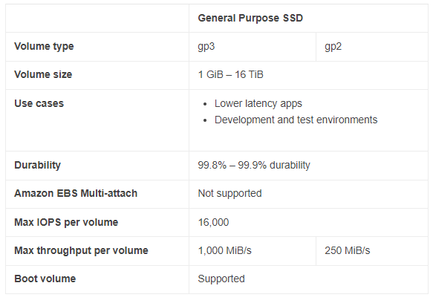

## Provisioned IOPS SSD

Provisioned IOPS SSD volumes are used for workloads that require high performance, lower latency, and higher throughput. Three types of Provisioned IOPS SSD volumes are **io2 Block Express**, **io2,** and **io1**. The **io2 Block Express** volume type is only supported with **R5b** instances.

The Provisioned IOPS SSD (**io1**) volume can be provisioned with a minimum of 100 and a maximum of 64,000 IOPS. The maximum ratio between provisioned IOPS and storage is 50:1. So you can provision a maximum of 50 IOPS per 1 GiB storage. The Provisioned IOPS SSD (**io2**) volume can be provisioned with a minimum of 100 and 256,000 IOPS, and the maximum ratio between the provisioned IOPS and storage is 1000:1. So you can provision a maximum of 1000 IOPS for 1 GiB storage.

Following is the performance chart for all the three types of Provisioned IOPS volumes types.

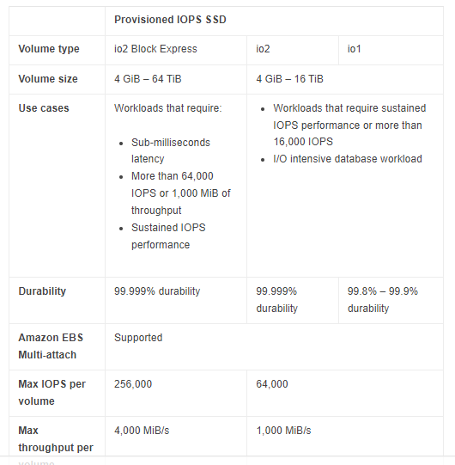

## Hard Disk Drives (HDD)

Hard disk drives are useful for large streaming workloads that require higher throughput. The dominant performance attribute for SSDs is throughput. Now we will discuss different categories of EBS volumes under HDD-backed volumes.

## Throughput optimized HDD

The throughput optimized HDD volume type is designed for frequently accessed workloads that require higher throughput. The **st1** is the only EBS volume type of throughput optimized HDD.

The Throughput optimized HDD (**st1**) volume provides a baseline throughput of 40 MiB/s per TiB storage provisioned up to 12,800 GiB. From 12,800 GiB to onward, a consistent throughput of 500 MiB/s is provisioned with storage.

Following is the performance chart of throughput optimized HDD EBS volumes.

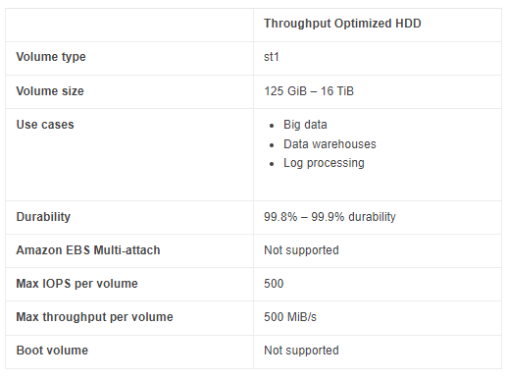

## Cold HDD

Cold HDD is another type of Hard disk drive provided by AWS for less frequently accessed workloads but higher throughput. Cold HDD is different from Throughput optimized based on IOPS. It has lesser IOPS than Throughput optimized HDD. Like Throughput Optimized HDD, the Cold HDD also provides a baseline throughput of 12 MiB/s per TiB storage provisioned. Following is the performance chart of Cold HDD EBS volume.

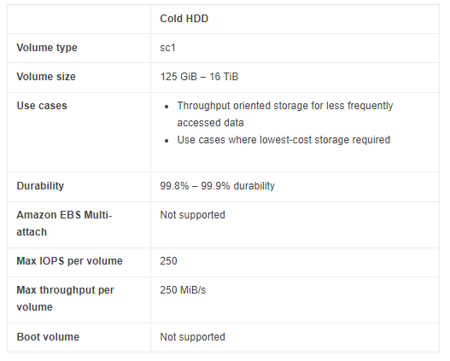

## Previous Generation

Previous generation drives are the hard disk drives used for workloads where performance is not a primary factor. It is also used for small datasets where the data is less frequently accessed. These are the previous generation hard drives, and amazon does not recommend using them. **Magnetic** is the only previous generation drive.

## Magnetic Disc

Magnetic is the only EBS volume type under the Previous Generation category and is used for workloads where data is infrequently accessed, and performance is not a primary factor. The following chart shows the key features of this storage type.

1. SC – Sequential Code – 250mbps
2. ST – Sequential throughputs – 512mbps
3. Normal Magnetic Disc- 125mbps

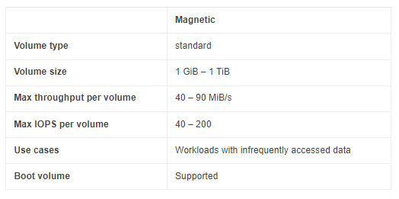

## Conclusion: -

Amazon provides different types of EBS volumes to provision required IOPS and Throughput for different types of workloads. There are different categories of Storage drives like SSD, HDD, and the previous generation, and each category includes different volume types like io1, io2, gp2, standard, etc. This guide describes all the features and uses cases of all the EBS volumes provided by AWS.

Important Notes: -

* When we boot the Disc, we can have used on gp2, gp3, provisional i/o, provisional i/o2, normal magnetic disc.
* Decrease volume is not support by EBS, that time your take downtime. You can only increase the Disc size.
* We can move from 1 volume to 2nd volume & its take 6 hrs.to implement –***SAN team will be doing this activity from backend***.
* We can attach the multiple instances in 1 volume for io1 & io2 not for gp2 & gp3 only.

**AFR (Annual failure rate)-** Amazon EBS volumes are designed to be highly available, reliable, and durable. io2 volumes in particular are designed to provide 99.999% durability with an annual failure rate (AFR) of 0.001%, where failure refers to a complete or partial loss of the volume.